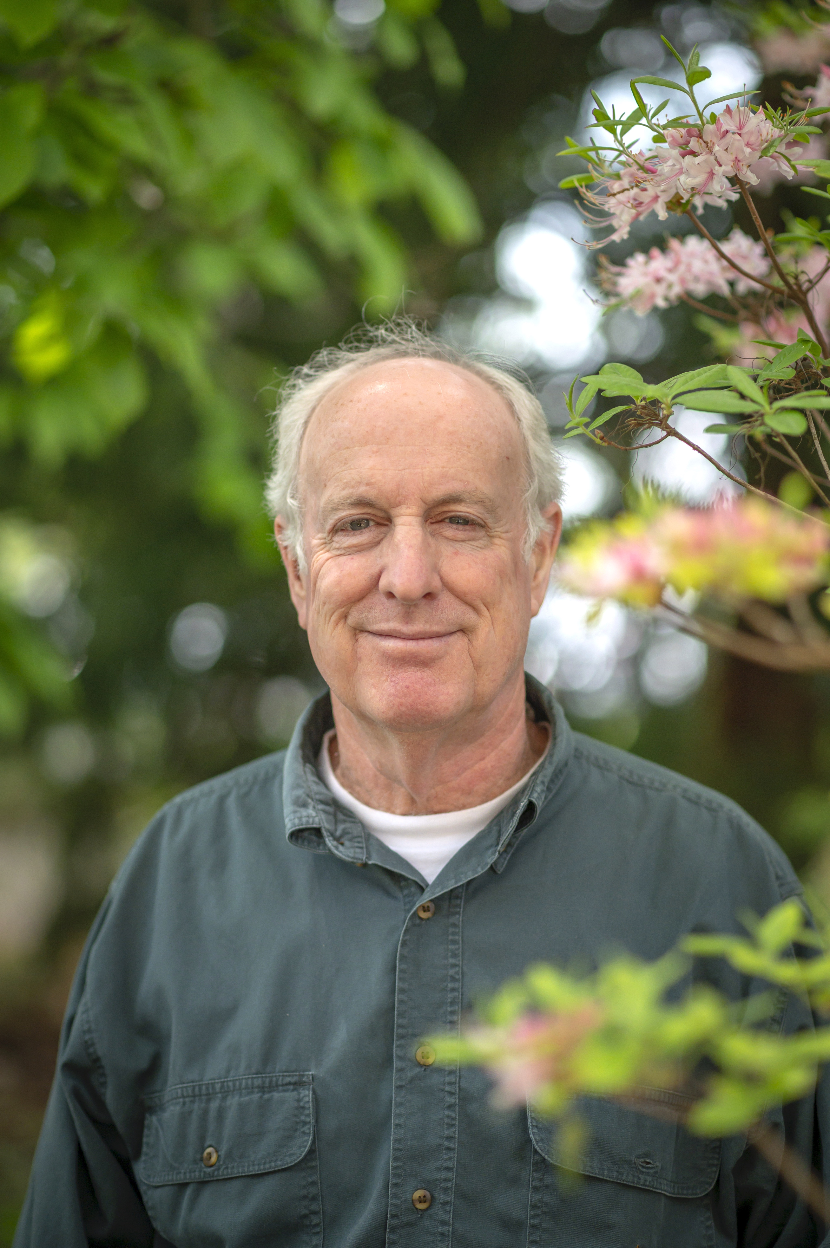

Renowned Entomologist, Wildlife Ecologist and Author to help

homeowners at the Annapolis Home Expo
NOV. 2, 2021-Doug Tallamy will join the Home Owners Expo as a featured speaker/educator a on Sunday. Feb. 27, 2022, 1PM. Doug is the T. A. Baker Professor of Agriculture in the Department of Entomology and Wildlife Ecology at the University of Delaware, where he has authored 105 research publications and has taught insect related courses for 41 years. Chief among his research goals is to better understand the many ways insects interact with plants and how such interactions determine the diversity of animal communities. His book Bringing Nature Home was published by Timber Press in 2007, The Living Landscape, co-authored with Rick Darke, was published in 2014; Nature's Best Hope, a New York Times Best Seller, was released in February 2020, and his latest book The Nature of Oaks was released by Timber press in March 2021. His awards include recognition from The Garden Writer’s Association, Audubon, The Garden Club of America and The American Horticultural Association.
“We are excited to have our shows back on track for the spring of 2022” says Scott Smith, President of Mid Atlantic Expos, “and really excited to have Doug join us to talk with our guests. He has a great following and has very relevant information to pass on to homeowners to help them with their property. “
For photos and additional information, email us at office@midatlanticexpos.com

CONTACT INFORMATION:
Scott Smith, Mid Atlantic Expos
410 878 2550
office@midatlanticexpos.com

